## **25+ high-resolution PM infographics (PDFs)**

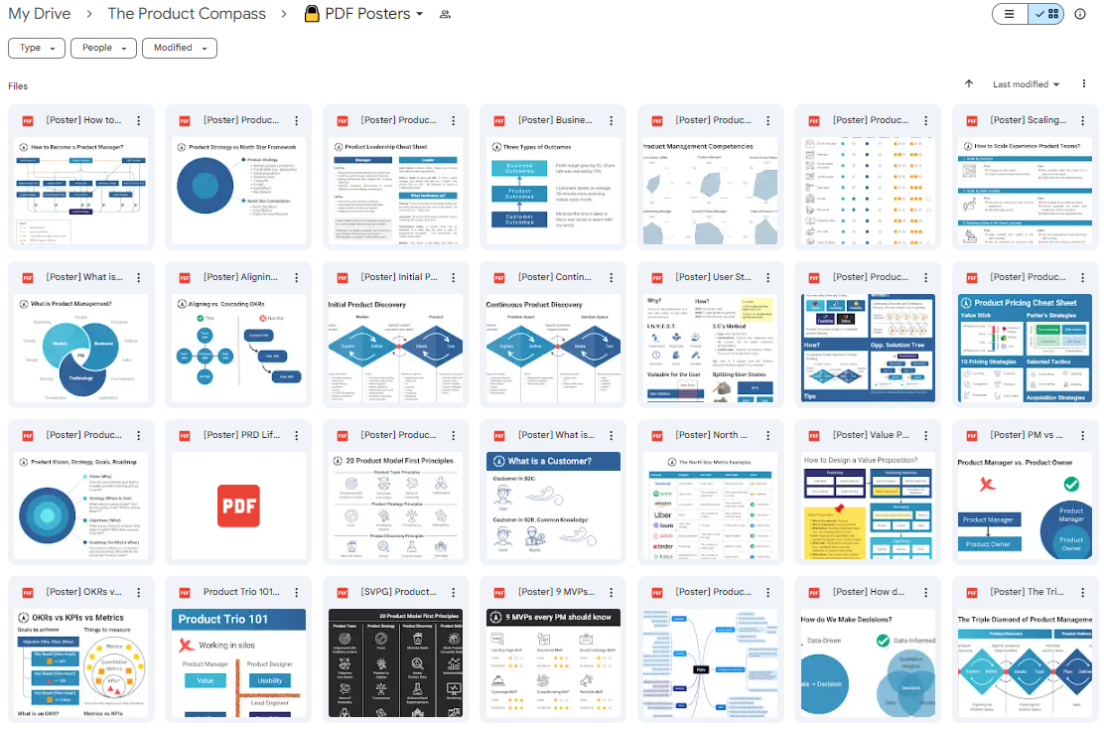

🎁 Download for free by subscribing to my newsletter. You can cancel anytime: <https://www.theproductcompass.tech/download-pm-posters>